

**Fitness and Lifestyle Documentation**

**(Template báo cáo cho các nhóm)**

|  |  |
| --- | --- |
| **Team: <Doctor Care>** | |
| **Group Member** | Nguyễn Hoàng Sơn (Leader)  Đỗ Thị Thảo  Nguyễn Việt Đức  Cao Quốc Trung  Đỗ Thế Đức |
| **Class** | T.2108A1 |

- Hanoi, 9/20222 -

**Table of Contents**

1. Problem Definition 4

i. Introduction 4

ii. Implementation Environment 4

User Stories 5

1.2 User type 1 (Admin) 5

i. Story 1 5

ii. Story 2 5

1.3 User type 2 (Customer) 6

i. Story 1 6

ii. Story 2 7

2. Flowchart 8

2.1 User 8

2.2 Admin 9

Database 10

2.3 DB Relationship Diagram 10

2.4 Table 1 (appointment_schedule) 10

2.5 Table 2 (examination_time) 11

2.6 Table 3 (examination_price) 11

2.7 Table 4 (tbl_specialty) 11

2.8 Table 5 (examination_schedule) 12

2.9 Table 6 (tbl_doctor) 12

2.10 Table 7 (examination_day) 13

2.11 Table 8 (tbl_contact) 13

2.12 Table 9 (tbl_admin) 13

2.13 Table 10 (role) 14

2.14 Table 11 (admins_Roles) 14

3. UI\UX 15

3.1 GUI 1 (Home Page) 15

3.2 GUI 2 (Booking Care Form) 15

3.3 GUI 3 (AppointmentSchedules) 16

3.4 GUI 4 (Doctors) 16

4. Summary 17

# Problem Definition

### Introduction

Health is one of the most important factors in today's world and should be our top priority. With the increasing number of diseases and the large number of urban populations, it becomes difficult to book an appointment for medical examination or treatment. There may be a person who wants to have their blood pressure, weight, etc. checked, and for this purpose they ask to continue to the clinic. Sometimes, all day after making an appointment, a person may forget this or may go to the hospital/clinic and wait for their turn. What individuals are looking for is a solution to help them book an appointment online to reduce waiting time.

* Proposed solution

There needs to be a web app called to help people book appointments online. The application will allow users to book an appointment and send feedback to the clinic, when they come to the clinic they will be given priority to check first without having to wait for their turn.

* Scale

Application will be managed by their clinic. We can manage the client's appointment schedule.

We can also manage the clinic's doctors by specialty.

### Implementation Environment

- Front End: HTML5, CSS4, Bootstrap / Thymeleaf, JavaScript, jQuery.

- Client & Server: Java 8 or higher, Java EE 7 or higher with IntelliJ IDEA OR with Visual Studio Code, MVC and Core

# User Stories

## User type 1 (Admin)

### Story 1

With more than 10 years of experience in the field of medical technology equipment and services, going to many different hospital routes across the country, witnessing queues, waiting for medical examination. Along with that, the journey to find doctors, hospitals to treat relatives, friends, acquaintances... has prompted the founding team to see that something needs to be done to contribute to making it easier for people to go to the doctor. easier, more convenient and more efficient.

“Besides, we also often see many patients who have gone to many places, met many doctors but the disease is not cured, it takes time for treatment, it costs money, leading to depression, frustration, give up. One of the important reasons is due to the wrong person, right disease (right doctor, right medicine, right method) with the patient's problem.

The current online appointment booking website will be a great thing in today's society, especially in the difficult time of the global epidemic - Covid-19. Besides being absolutely safe for patients, it also helps patients save a lot of time when they don't have to wait.

### Story 2

Regarding the cause of the above situation, according to experts in medical administration, it is because patients have no sense of community, have not registered for medical examination before and most of them do not receive medical examination on time. of specialists, you can go to the doctor every day. In advanced countries and even countries in the region, except for emergencies, patients who come for medical examination must register with a doctor or hospital in advance. Check up on the appointment of the specialist and always determine that if you go to the doctor today, it is considered not to do anything else. The appointment of medical examination will help the hospital to have a specific work plan, carefully prepared patient records in advance, especially in the case of follow-up visits. Confusion and haste will no longer occur and the doctor will have a comfortable mood when examining, then the quality of medical examination and treatment will also be greatly increased

According to health administrators, all of the above problems are due to habits, lasting for many years, our behavior when going to the doctor has been neglected, allowing bad habits to develop. with justification, insurmountable difficulties...

During the subsidy period, hospital fees were a very minor issue for both patients, hospitals and doctors. When a patient sees an illness, he or she comes for treatment, the doctor sees the need for an operation, and the hospital does not have to worry about losing revenue. Everything was taken care of by the State, doctors only focused on their expertise, but due to subsidies, some conditions and means of treatment were also limited.

Gone are the days of subsidies. Currently, in order to have funding for the operation of the hospital, each patient who is hospitalized for treatment needs to have a source of funding from the patient himself, his family, the State, and health insurance. and other forms of insurance, from charity and social funding... And hospital fees are now a big concern of patients. There have been many cases where patients did not agree to stay in the hospital and especially did not agree to surgery for the sole reason of not having money to pay hospital fees.

## User type 2 (Customer)

### Story 1

Called 6 times to many places for emergency help, I can't help but watch my father die

From the health hotline of Go Vap district, Mr. M.H. continued to be instructed to call the Health Station of Ward 16 (Go Vap District) at the phone number of Dr. Giang. However, when contacted, Dr. Giang said that the ward medical office only gave emergency treatment for COVID-19 cases, not stroke.

Mr. M.H. Called the Go Vap district health center, he was asked to wait and give the phone number of Dr. Thuong, head of the medical station in Ward 16, Go Vap. After nearly 5 minutes of waiting but no one came to the emergency room, Mr. M.H. continue to call 911 Emergency Center and will be informed that they will be accepted.

After nearly 20 minutes, 115 Emergency Center called back to ask about the situation and then instructed his family to find a way to take Mr. H. to the hospital, but could not access the emergency.

"They told me to feel and see if my father's heart was still beating, but at that time my father stopped breathing. They told me to find a way to bring myself to 175 Military Hospital for emergency, but there is no other way," said Mr. M.H. tell.

At 7:30 a.m., his family took Mr. H. to Military Hospital 175. However, the doctor determined that Mr. H had had a cardiac arrest before entering the hospital.

According to Mr. H's family, at 7:45 a.m., a team of 4 people from the ward health station came down, but at this time Mr. H. was taken to the hospital.

### Story 2

As an adult, they often suffer from diseases such as bone and joint pain, cardiovascular disease, and blood pressure. These diseases are characterized by the fact that they cannot be completely cured, but can only be controlled and restrained from the development of the disease. . Therefore, having a person who regularly monitors and takes care of the health of the elderly is essential, finding home health care services for the elderly is the most appropriate solution at this time.

# Flowchart

## User

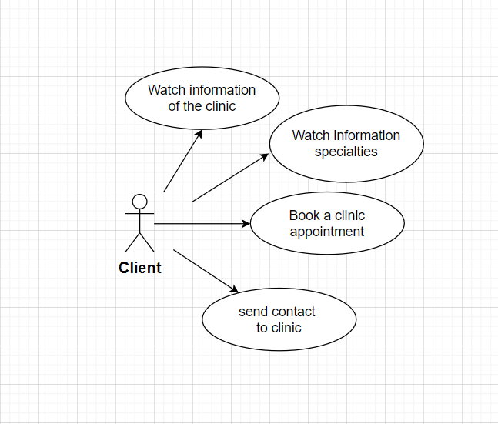

**Customer:**

Customers visiting our homepage will be able to view information about the clinic and its specialties. When you find it necessary for your health, you will book an appointment with a time and service fee that suits you. Or you can send a consultation to the clinic to get the best information about your own health status.

## Admin

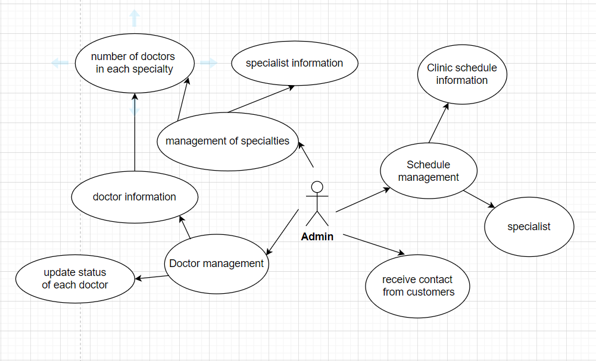

**Admin**:

Our We will manage the doctors, specialties, appointment information of customers. From the booking information of each customer, we will control and follow your request.

# Database

## DB Relationship Diagram

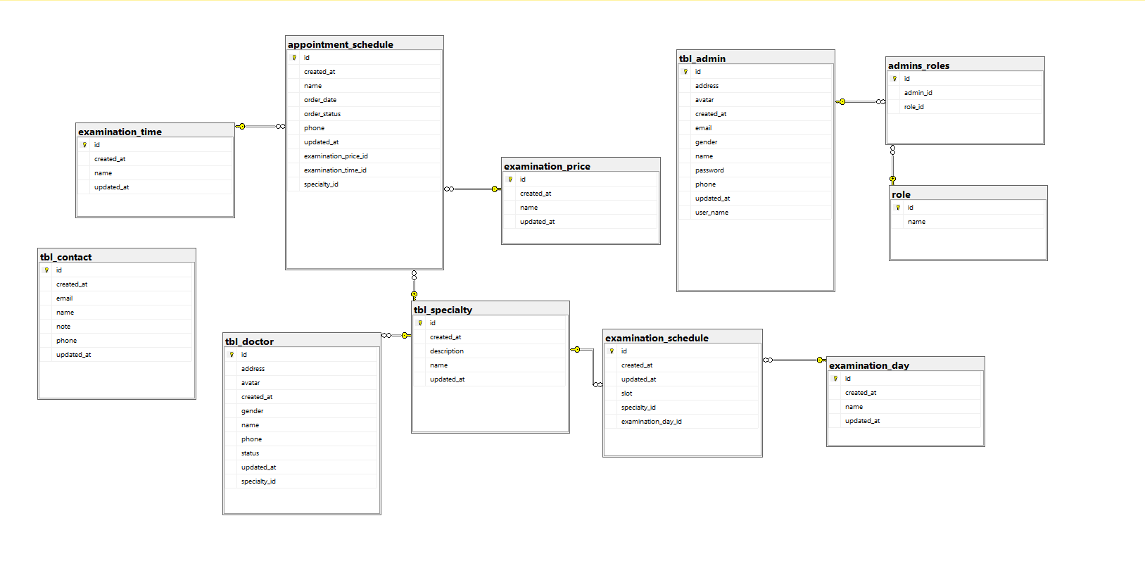

## Table 1 (appointment_schedule)

|  |  |  |  |
| --- | --- | --- | --- |
| **Column Name** | **Data Type** | **Constraint** | **Description** |
| id | bigint | primary key | Indentity of the appointment_schedule |
| name | varchar(255) | not null | Name of the cútomer |
| phone | varchar(255) | not null | Phone contact number |
| Order_date | varchar(255) | not null | customer's booking date |
| Order_status | varchar(255) | not null | the status of the appointment |
| speciality_id | bigint | foreign key (tbl_specialty) | Identify that doctor's specialty |
| examination_price_id | bigint | foreign key (examination_price) | Determining the price of medical services |
| examination_time_id | bigint | foreign key (tbl_specialty) | Determine the examination time frame |
| created_at | date | auto genenrate | The date created in the app system of that facility |
| update_at | date | auto update | The date that data of the health facility got updated |

## Table 2 (examination_time)

|  |  |  |  |
| --- | --- | --- | --- |
| id | bigint | primary key | Indentity of a examination_time table |
| name | varchar(255) | not null | examination time frame |
| created_at | date | auto generate | The date that the specialty is created in the app system |
| update_at | date | auto generate | The date that the specialty is updated in the app system |

## Table 3 (examination_price)

|  |  |  |  |
| --- | --- | --- | --- |
| id | bigint | primary key | Indentity of examination_price table |
| name | varchar(255) | Not null | examination service price |
| created_at |  | auto generate | The day the doctor profile created in the app |
| updated_at |  | auto generate | The day the doctor profile updated in the app |

## Table 4 (tbl_specialty)

|  |  |  |  |
| --- | --- | --- | --- |
| id | bigint | primary key | Indentity of specialty in the system |
| name | varchar(255) | not null | Name of the specialties |
| Description | Varchar(225) | Not null | specialty description of the clinic |
| created_at | date | auto generate | The date that the specialty is created in the app system |
| update_at | date | auto generate | The date that the specialty is updated in the app system |

## Table 5 (examination_schedule)

|  |  |  |  |
| --- | --- | --- | --- |
| id | bigint | primary key | Indentity of a examination_schedule table |
| slot | varchar(255) | not null | number of specialists in each daily time frame |
| speciality_id | bigint | foreign key (tbl_specialty) | Identify that id of specialty table |
| examination_day_id | bigint | foreign key (examnination_day) | Identify that id of examination_day table |
| created_at | date | auto generate | Auto generate created date |
| updated_at | date | auto generate | Auto update the day Role got updated |

## Table 6 (tbl_doctor)

|  |  |  |  |
| --- | --- | --- | --- |
| id | bigint | primary key | Indentity of a doctor in the system |
| name | varchar(255) | Not null | Name of the doctor |
| gender | bit | Not null | Gender of the doctor |
| phone | varchar(10) | Not null | Phone number to contact with doctor |
| address | varchar(255) | Not null | Address of the doctor |
| image | varchar(255) |  | Image of the doctor |
| status | bit |  | Update status of doctor’s |
| speciality_id | bigint | foreign key (tbl_specialty) | Identify that doctor's specialty |
| created_at |  | auto generate | The day the doctor profile created in the app |
| updated_at |  | auto generate | The day the doctor profile updated in the app |

## Table 7 (examination_day)

|  |  |  |  |
| --- | --- | --- | --- |
| id | bigint | primary key | Indentity of a examination_day table |
| name | varchar(255) | Not null | clinic day of the week |
| created_at | date | auto generate | Auto generate created date |
| updated_at | date | auto generate | Auto update the day Role got updated |

## Table 8 (tbl_contact)

|  |  |  |  |
| --- | --- | --- | --- |
| id | bigint | primary key | Indentity of a tbl_contact table in the system |
| name | varchar(255) | Not null | Name of customer |
| phone | varchar(10) | Not null | Phone ò customer |
| email | Varchar(255) | Not null | Email of customer |
| Note | Varchar(255) | Not null | Note of customer |
| Contact_status | bit |  | Update status of customer |
| created_at | date | auto generate | Auto generate created date |
| updated_at | date | auto generate | Auto update the day Role got updated |

## Table 9 (tbl_admin)

|  |  |  |  |
| --- | --- | --- | --- |
| id | bigint | primary key | Indentity of a admin in the system |
| avatar | vachar(max) | not null | image of the admin |
| Name | Varchar(255) | Not null | Full name of the admin |
| email | varchar(255) | not null, unique | Register email of the admin |
| phone | varchar(255) | not null, unique | Phone number of the admin |
| gender | bit | not null | Gender of the admin |
| address | Varchar | Not null | Address of the admin |
| username | varchar(255) | not null, unique | User name for login |
| password | varchar(255) | not null | Password for login |
| created_at | date | auto generate | Auto generate created date |
| updated_at | date | auto generate | Auto update the day profile got updated |

## Table 10 (role)

|  |  |  |  |
| --- | --- | --- | --- |
| id | bigint | primary key | Indentity of role table in the system |
| name | varchar(255) | Not null | Name of role |
| created_at | date | auto generate | Auto generate created date |
| updated_at | date | auto generate | Auto update the day Role got updated |

## Table 11 (admins_Roles)

|  |  |  |  |
| --- | --- | --- | --- |
| id | bigint | primary key | Indentity of admin_roles |
| role_id | bigint | foreign key (tbl_admin) | Link to the identity of the tbl_admin table |
| admin_id | bigint | foreign key (role) | Link to the id of role table |
| created_at | date | auto generate | The day the doctor profile created in the app |
| updated_at | date | auto generate | Auto update the day appointment status got updated |

# UI\UX

## GUI 1 (Home Page)



## GUI 2 (Booking Care Form)

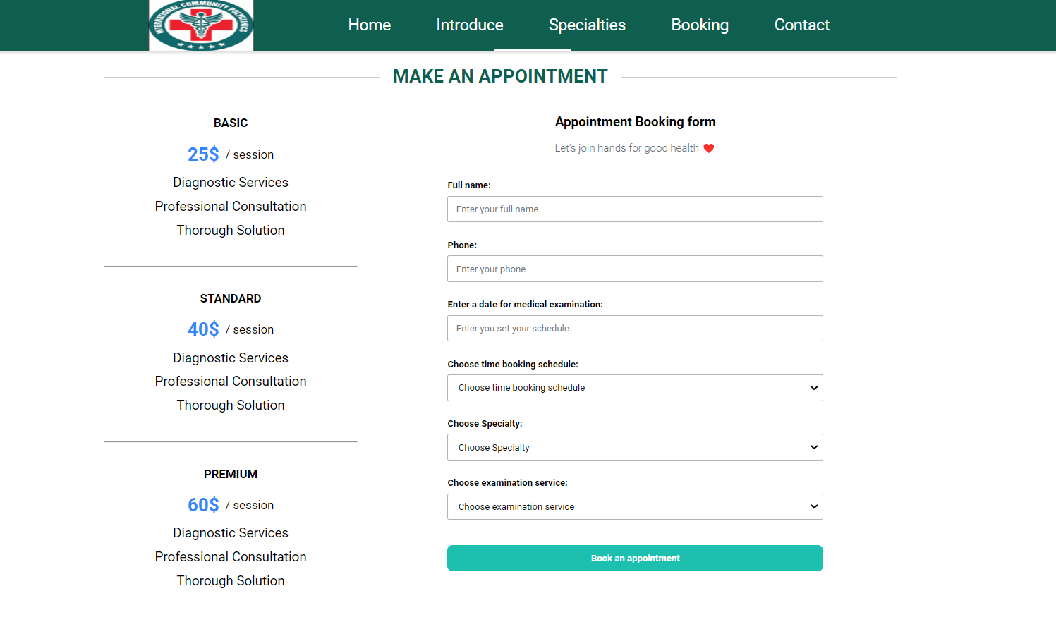

## GUI 3 (AppointmentSchedules)

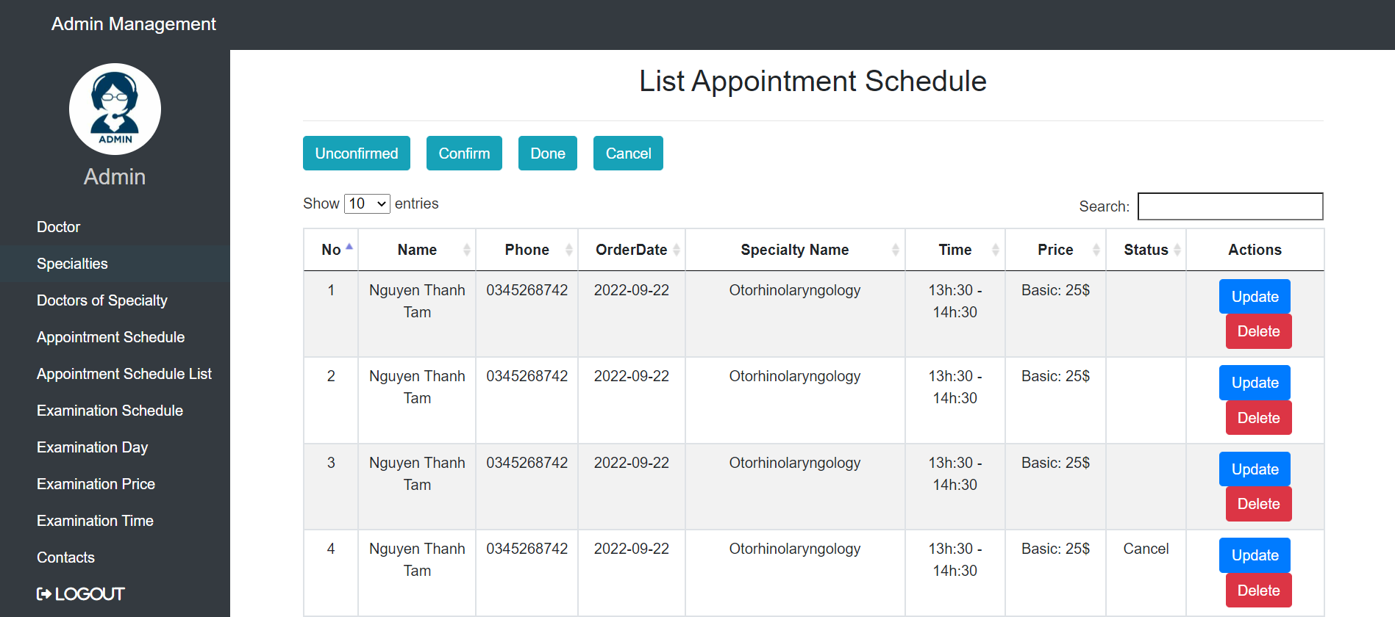

## GUI 4 (Doctors)

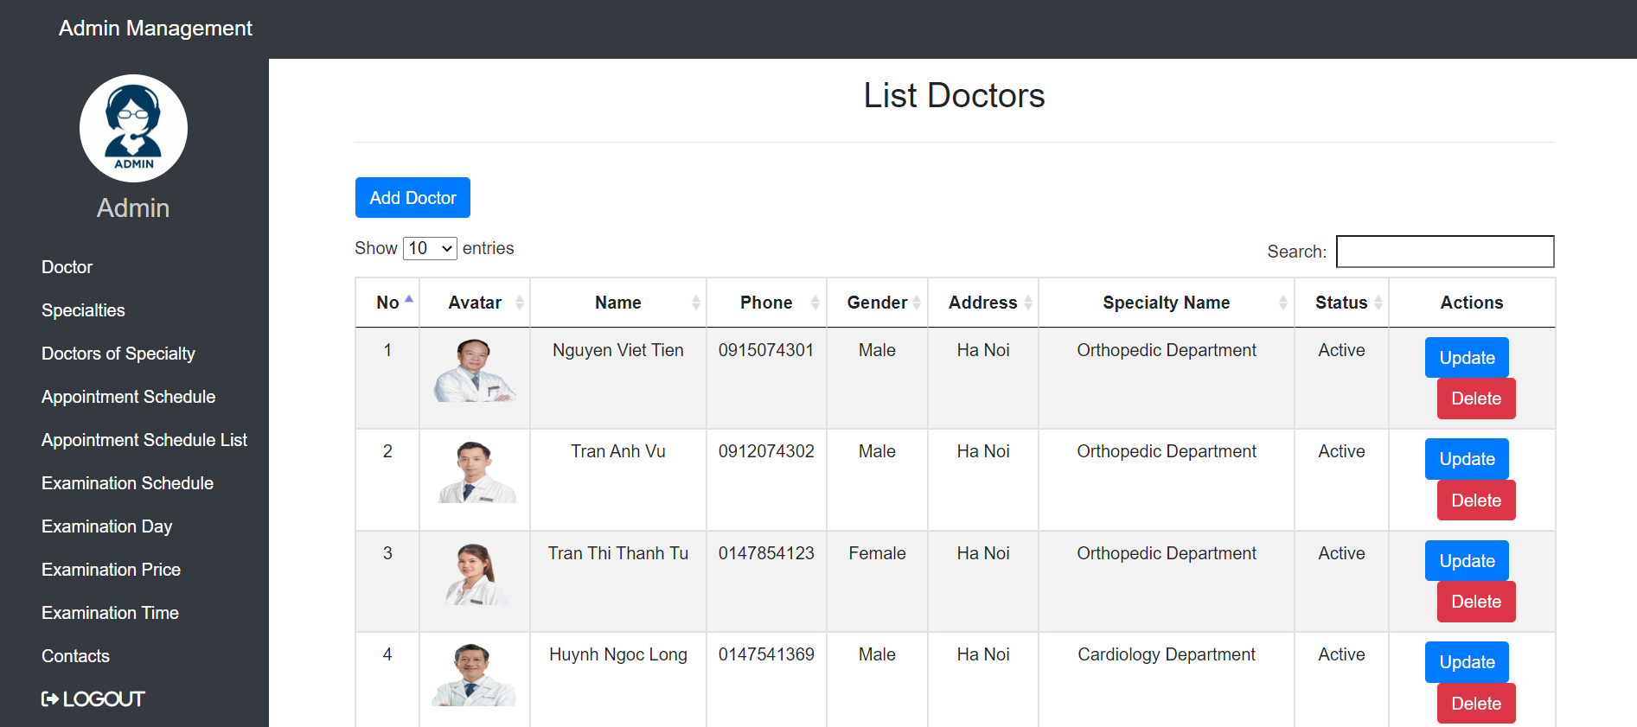

# Summary

1. **The parts that have been done:**
   1. The main flow of the problem has been built: the customer can book an appointment online
   2. Admin: Manage appointments, doctors, specialties of the clinic
2. **Unfinished:**
   1. The management system has many shortcomings
   2. After making an appointment, customers still have to wait for a response from the clinic
3. **Experience from the project:**
   1. From this session, we learned more about the strengths and weaknesses of working together as a team. Had a great experience working on a project. Those are also useful experiences later when working for us.
   2. Thank you to the teachers who helped us to have a more realistic view of our topic from which to have experience to do the following projects.